CSCI 3303 Networking Data Communication

Project #2: Chat Programming by JavaFx

Due Date: Midnight, Dec. 6, 2021

This project should be a GUI (Graphic User Interface) version of chat programming among n clients based on TCP written in JavaFx program language.

**Requirements:**

1. This system consists of 1 server with n clients.

2. ServerSocket class and Socket class in java.net package should be used.

3. Use host name: “127.0.0.1” and port number: “9876”.

4. The others follow the instruction in class.

**Rubric:**

1. Chat program properly working: pass the project.
2. Displaying ‘current client list’ in the dialog box: bonus points will be given.

**Sample Run:** chat project

1. Run server package 🡪 then click ‘start’ button to display [server start] to wait client(s) to be accessed.

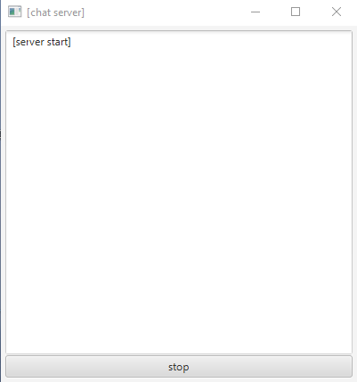

1. Run client package n(=3) times 🡪 then, enter different nicknames for example aaa, bbb, and ccc and press ‘access’ button to connect to chat server by displaying [access chatroom].

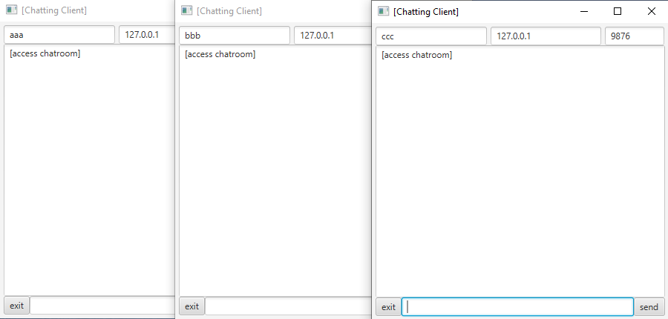

1. Next, chat each other.

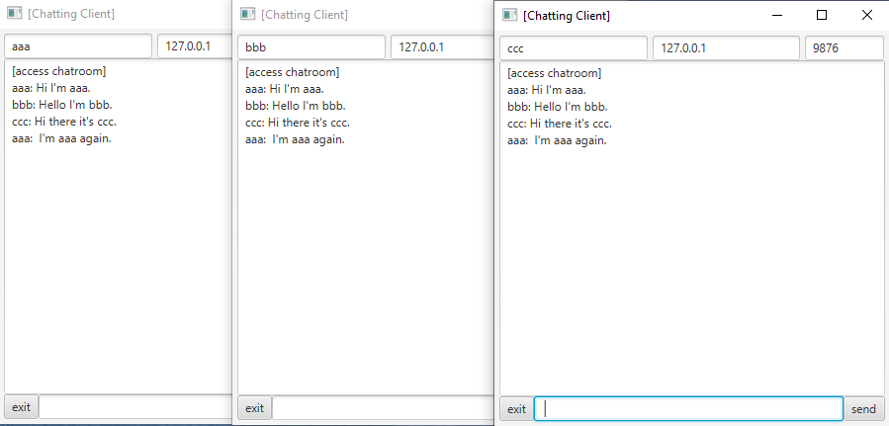

1. Client can exit by clicking ‘exit’ button to exit the chatroom by displaying [exit chatroom].

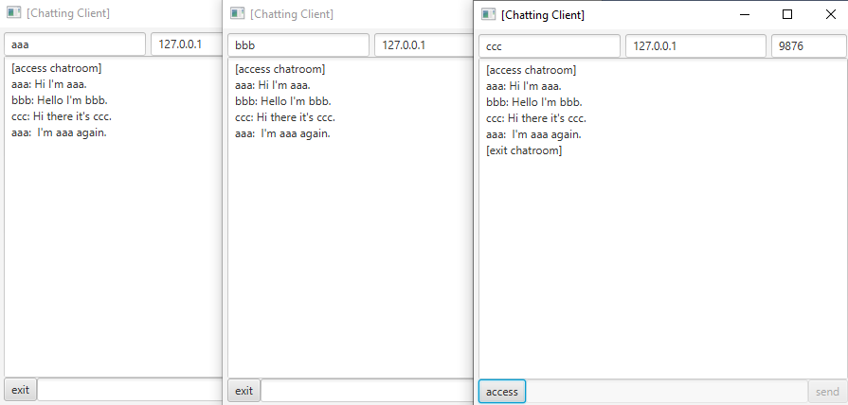

1. Finally, no client left in chatroom, server will be closed by clicking ‘stop’ button to display [server stop].

